**Add in Section 3.7:**

**Parallel Operation of Three Phase Alternator:**

**Interconnection**of the electric power systems is necessary from the cost-effective point of view and also for reliable and**Parallel Operation.** Interconnection of AC power systems requires synchronous generators to work in **parallel**with each other. In generating stations, two or more generators are connected in parallel. The alternators are situated at different locations forming a **grid**connected system.

They are connected parallel through transformer and transmission lines. Under normal working conditions all the generators and synchronous motors in an interconnected system work in synchronism with each other. A machine has to be adjusted for most favourable working efficiency and greater reliability if the generators are connected in parallel.

As the load increases beyond the generated capacity of the connected units, additional generators are parallel to carry the load. Similarly, if the load demand decreases, one or more machines are taken off the line as per the requirement. It allows the units to operate at a higher efficiency.

**Necessity of Parallel Operation:**

Alternators are operated in parallel for the following reasons:

1. Several alternators can supply a bigger load than a single alternator.
2. One or more alternators may shut down during the period of light loads. Thus, the remaining alternator operates at near or full load with greater efficiency.
3. When one machine is taken out of service for its scheduled maintenance and inspection, the remaining machines maintain the continuity of the supply.
4. If there is a breakdown of the generator, there is no interruption of the power supply.
5. Number of machines can be added with disturbing the initial installation according to the requirement to fulfil the increasing future demand of the load.
6. Parallel operation of the alternator, reduces the operating cost and the cost of energy generation.
7. It ensures the greater security of supply and enables overall economic generation.

**Condition for Parallel Operation of Alternator:**

There are some conditions to be satisfied for parallel operation of the alternator. Before entering into that, we should understand some terms which are as follows.

1. The process of connecting two alternators or an [alternator](https://www.electrical4u.com/alternator-or-synchronous-generator/) and an infinite bus bar system in parallel is known as synchronizing.
2. Running machine is the machine which carries the load.
3. Incoming machine is the alternator or machine which has to be connected in parallel with the system.

The condition that needs to be satisfied are as follows:

1. The phase sequence of the incoming machine [voltage](https://www.electrical4u.com/voltage-or-electric-potential-difference/) and the bus bar voltage should be identical.
2. The [RMS](https://www.electrical4u.com/rms-or-root-mean-square-value-of-ac-signal/) line voltage (terminal voltage) of the bus bar or already running machine and the incoming machine should be the same.
3. The phase angle of the two systems should be equal.
4. The frequency of the two terminal voltages (incoming machine and the bus bar) should be nearly the same. Large power transients will occur when frequencies are not nearly equal.

**Advantages of Parallel Operating Alternators:**

1. When there is maintenance or an inspection, one machine can be taken out from service and the other alternators can keep up for the continuity of supply.
2. Load supply can be increased.
3. During light loads, more than one [alternator](https://www.electrical4u.com/alternator-or-synchronous-generator/) can be shut down while the other will operate in nearly full load.
4. High efficiency.
5. The operating cost is reduced.
6. Ensures the protection of supply and enables cost-effective generation.
7. The generation cost is reduced.
8. [Breaking](https://www.electrical4u.com/rating-of-circuit-breaker-short-circuit-breaking-making-current/) down of a generator does not cause any interruption in the supply.
9. Reliability of the whole power system increases.

### Synchronization of Alternators:

The process of matching parameters such as voltage, frequency, phase angle, phase sequence and waveform of alternator (generator) or other source with a healthy or running power system is called synchronization.

Generator cannot deliver power to electric power system unless its voltage, frequency and other parameters are exactly matched with the network. Synchronization is accomplished by controlling the exciter current and the engine speed of the generator.

The need for synchronization arrives, particularly when two or more alternators are working together to supply the power to the load. This is because electrical loads are not constant and they vary with time and hence they necessitate the interconnection of two or more alternators operating in parallel to supply larger loads.

Synchronization matches various parameters of one alternator (or generator) to another alternator or to the bus bar. The process of synchronization is also called as paralleling of alternators.

### Methods of Synchronization of Alternator:

There are different techniques being available for the synchronization of alternators. The primary purpose of these techniques is to check all four conditions discussed above. The common methods used for synchronizing the alternators are given below.

1. Three Dark Lamps Method

2. Two Bright, One Dark Method

3. Synchroscope Method

#### Three Dark Lamps Method:

The figure below shows the circuit for bright lamp method used to synchronize the alternators. Assume that alternator is connected to the load supplying rated voltage and frequency to it. Now the alternator-2(A2) is to be connected in parallel with alternator-1 (A1). Three lamps (each of which is rated for alternator terminal voltage) are connected across the switches of the alternator-2.

From the figure it is clear that the moment when all the conditions of parallel operation are satisfied, the lamps should be more or less dark. To synchronize the alternator-2 with bus bar, the prime mover of the alternator-2 is driven at speed close to the synchronous speed decided by the bus bar frequency and number of poles of the alternator.

Now the field current of the alternator-2 (A2) is increased till voltage across the machine terminals is equal to the bus bar voltage (by observing the readings on voltmeters). If lamps go ON and OFF concurrently, indicating that the phase sequence of alternator-2 matches with bus bar. On the other hand, if they ON and OFF one after another, it resembles the incorrect phase sequence. By changing the connections of any two leads of alternator-2 after shutting down the machine, the phase sequence can be changed.

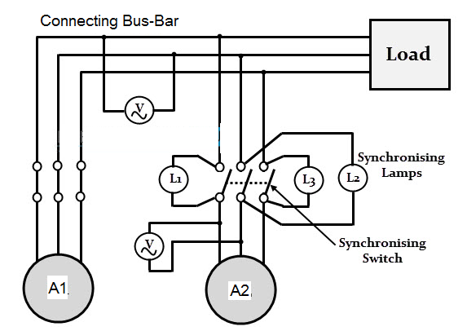

#### Fig. -- Three Dark Lamps Method

Depending on the frequency difference between alternator-2 (A2) voltage and bus bar voltage, ON and OFF rate of these lamps is decided. Hence, the rate of flickering has to be reduced to match the frequency. This is possible by adjusting the speed of alternator by its prime mover control. When all these parameters are set, the lamps become dark and then the synchronizing switch can be closed to synchronize alternator-2 with alternator-1.

The major disadvantage of this method is that rate of flickering only indicates the difference between the alternator-2 and the bus bar. But the information of alternator frequency in relation to bus bar frequency is not available in this method. Presume, if the bus bar frequency is 50Hz, the rate of flickering of lamps is same when the frequency of the alternator is either 51 or 49 Hz, as the difference in these two cases is 1Hz.

#### Two Bright and One Dark Lamp Method:

The connections for this method are shown in figure below and it is useful in finding whether the alternator frequency is lower or higher than the bus bar frequency.

Here, the lamp L2 is connected across the pole in the middle line of synchronizing switch as similar to the dark lamp method, whereas the lamps L1 and L3 are connected in a transposed manner.

The voltage condition checking is similar to the previous method and after it, the lamps glow bright and dark one after another. The lower or higher value of alternator frequency in comparison with bus bar frequency is determined by the sequence in which the lamps become dark and bright.

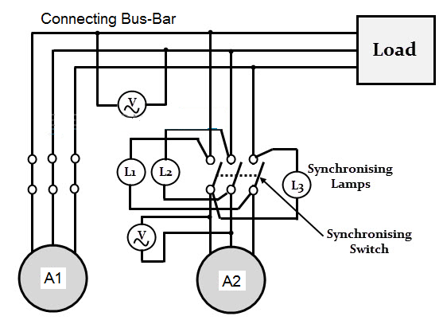

#### Fig. -- Two Bright and One Dark Lamp Method

The sequence of becoming bright and dark L1- L2 – L3 indicates that the incoming generator frequency is higher than the bus bar frequency. Hence, the alternator speed has to be reduced by prime mover control till the flickering rate is brought down to a small.

On the other hand, the sequence flickering L1- L3 – L2 indicates that incoming alternator frequency is less than that of bus bar. Therefore, the speed of the alternator is increased by the prime mover till the rate of flickering is brought down to as small as possible. The synchronizing switch is then closed at the instant when lamps L1 and L3 are equally bright and lamp L2 is dark.

The drawback of this method is that the correctness of phase sequence cannot be checked. Though, this requirement is unnecessary for permanently connected alternators where checking of phase sequence is enough to be carried out for the first time of operation alone.

#### Synchroscope Method:

It is similar to the two bright and one dark lamp method and indicates whether the alternator frequency is higher or lower than the bus bar frequency. A synchroscope is used for better accuracy of synchronization and it consists of two pairs of terminals.

One pair of terminals marked as ‘existing’ has to be connected across the bus bar terminals or to the existing alternator and other pair of terminals marked as ‘incoming’ has to be connected across the terminals of incoming alternator. The synchroscope has circular dial over which a pointer is hinged that is capable of rotating in clockwise and anticlockwise directions.

## 

#### Fig. -- Synchroscope Method

After the voltage condition is checked, the operator has to check the synchroscope. The rate at which the pointer rotates indicates the difference of frequency between the incoming alternator and the bus bar. Also, the direction to which the pointer rotates (to either fast or slow) gives the information, whether the incoming alternator frequency is higher or lower than the bus bar frequency and hence the pointer moves either fast or slow.

The suitable correction has to be made to control the speed of the alternator so as to bring the rate of rotation of pointer as small as possible. Hence, synchroscope along with voltmeters are enough for synchronization process. However, in most of the cases a set of lights along with synchroscope is used as a double-check system. These are the methods of synchronizing the generators.

This procedure must be done cautiously to prevent the disturbances in the power system as well as to avoid a serious damage to the machine. Only three lamps methods are not preferred today due to less accuracy and manual operation. These processes need an expert and experienced person to handle the equipment while synchronizing. In most cases synchroscope method with set of lamps is used as mentioned above. Modern synchronization equipments automate the whole synchronization process with the use of microprocessor based systems that avoids manual lamps and synchroscope observations. These methods are easier to manage and more reliable.

**Effect of Change of Excitation:**

A change in the excitation of an alternator running in parallel with other affects only its KVA output; it does not affect the KW output. A change in the excitation, thus, affects only the power factor of its output. Let two similar alternators of the same rating be operating in parallel, receiving equal power inputs from their prime movers. Neglecting losses, their kW outputs are therefore equal. If their excitations are the same, they induce the same emf, and since they are in parallel their terminal voltages are also the same. When delivering a total load of I amperes at a power-factor of cosФ, each alternator delivers half the total current and I1 = I2 = I/2.

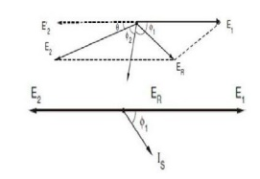

Fig.---

Since their induced emfs are the same, there is no resultant emf acting around the local circuit formed by their two armature windings, so that the synchronizing current, Is, is zero. Since the armature resistance is neglected, the vector difference between E1 = E2 and V is equal to, I1Xs1 I2Xs2 , this vector leading the current I by 900, where XS1 and XS2 are the synchronous reactances of the two alternators respectively.

Now consider the effect of reducing the excitation of the second alternator. E2 is therefore reduced as shown in Figure. This reduces the terminal voltage slightly, so let the excitation of the first alternator be increased so as to bring the terminal voltage back to its original value. Since the two alternator inputs are unchanged and losses are neglected, the two kW outputs are the same as before. The current I2 is changed due to the change in E2, but the active components of both I1 and I2 remain unaltered. It can be observed that there is a small change in the load angles of the two alternators, this angle being slightly increased in the case of the weakly excited alternator and slightly decreased in the case of the strongly excited alternator. It can also be observed that I1 + I2 = I, the total load current.

## Load Sharing of Alternators:

Load Sharing For alternators in parallel, change in field excitation will mainly change the operating power factor of the generator and has primarily no effect on the active power delivered by the generators (change in power factor will change the total current of an alternator thereby changing copper loss. The output active power will alter through a very small amount). The control of active power shared between alternators is affected by changing the input power to the prime mover. For example, in a thermal power station: having alternators driven by steam turbines, an increase of throttle opening and thus allowing more steam into the turbine will increase the power input; in a hydro station, the power input is controlled by water inlet into the turbine. The prime-mover, speed-load characteristics thus determine the load sharing between the alternators.

Consider for straightforwardness, a two machine case, consisting of two non-salient pole synchronous machines (generators) 1 and 2 respectively coupled to prime-movers 1 and 2 Figure below, the speed-load characteristics of the prime- movers. Assume that initially the two generators share equal active power and it is now required to transfer a certain amount of power from unit 1 to unit 2, the total power remaining constant.

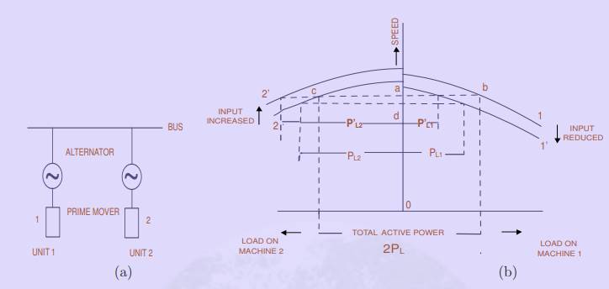

Fig---

The initial operating points are indicated on the characteristic by points b and c, the bus bar speed (or frequency) being given by the point a. The load on each machine is PL. the total load being 2PL. To reduce the load on unit 1, its input is decreased (by reducing the throttle opening) so that the prime-mover characteristic is now given by 1′.

The total load being constant, the loads shared by the machines are

machine 1 → PL1,

machine 2 → PL2,

the total load being PL1 +PL2 = 2PL,

and the bus frequency given by the point d is reduced. To maintain the bus frequency constant at its original value (given by point a) the input to unit 2 must be suitably increased so that its speed-load characteristic is given by 2′ .

The final load sharing is thus given by

machine 1→ P ′ L1 ,

machine 2 → P ′ L2 and

P ′ L1 + P ′ L2 = 2PL